# Activity

**Step 1)** One of the ways archeologists analyze magnetometry maps is by comparing them with other studies, such as contour maps and aerial photos. Compare the contour (left) and magnetometry (right) maps below from Big Hidatsa Village, another Knife River site. What is the significance of the lodge depression outlined by the small square?

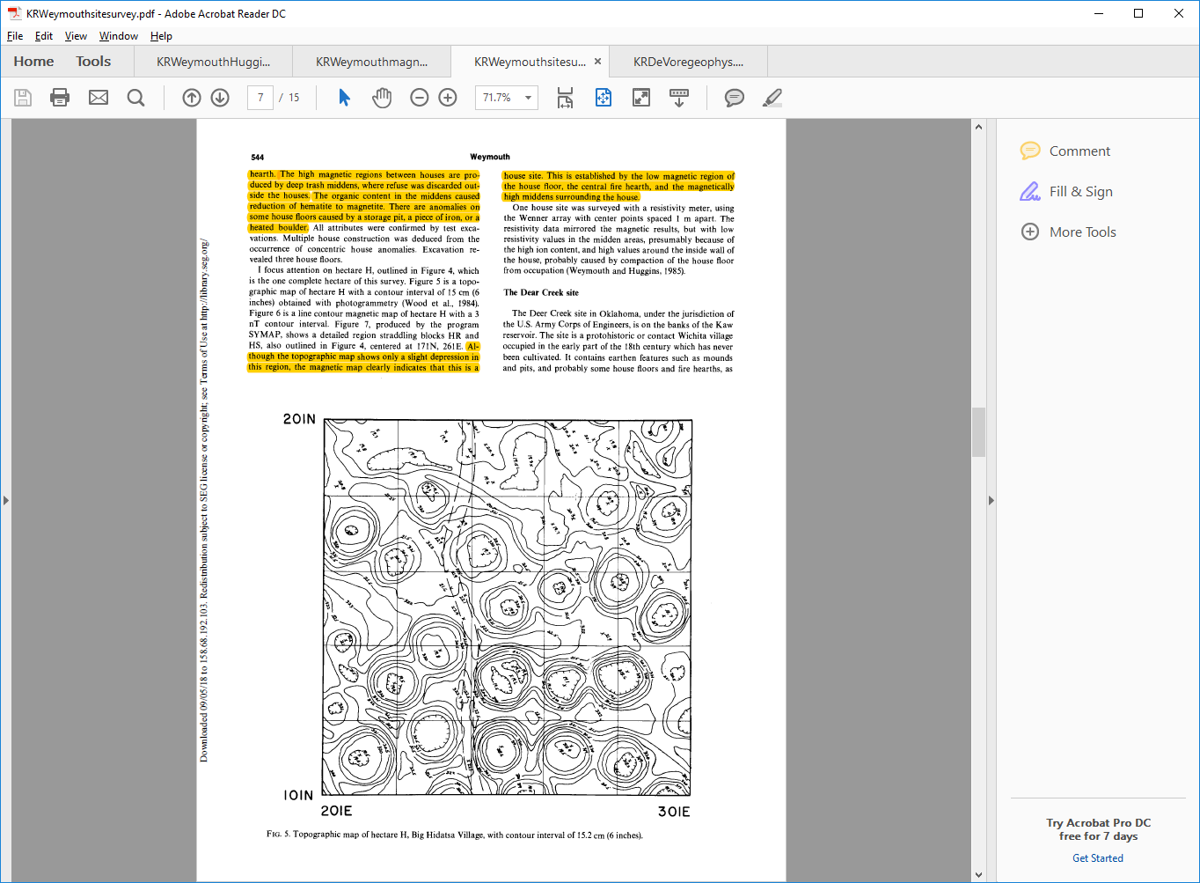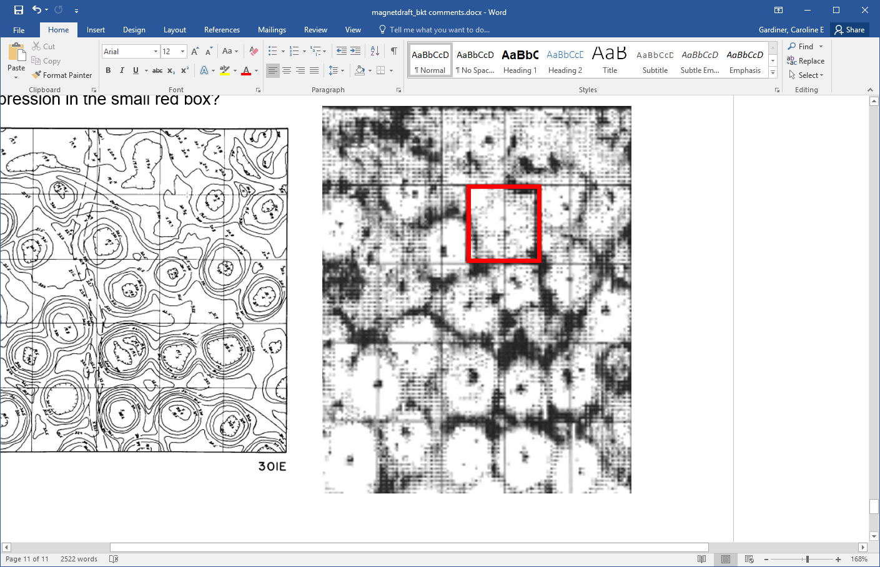

**Step 2)** Continue to examine the two maps. Are there more lodge impressions shown in the magnetometry results that do not appear on the contour map? How many lodges total are there?

**Step 3)** Given that between 10 and 20 people lived within each lodge, how large was the village population? How might archeologists interpret the changing number of earthlodges over time?